Enterprise Kubernetes Security Platform on Amazon EKS

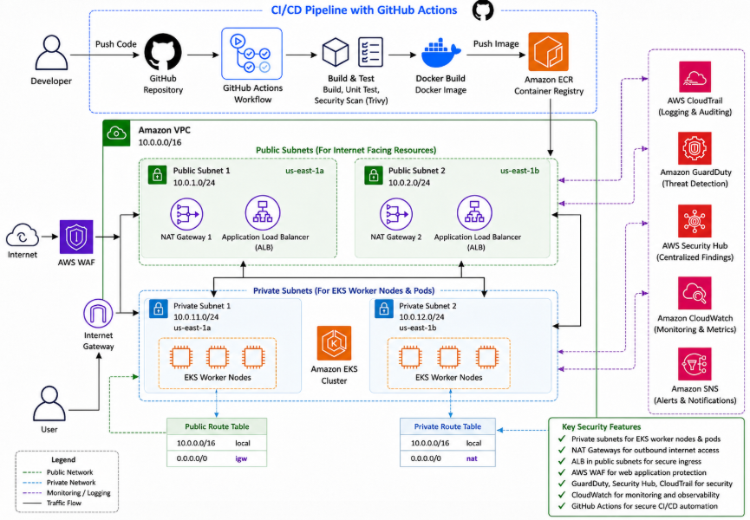

Step 1: The developer writes or updates the application code.

Step 2: The code is pushed to a GitHub Repository, which stores the project files and tracks code changes.

Step 3: GitHub Actions automatically starts the CI/CD workflow when new code is pushed.

Step 4: GitHub Actions checks out the code, builds the app, runs tests, scans it with Trivy, and builds the Docker image.

Step 5: Amazon ECR stores the finished Docker image, which is the packaged version of the application.
Step 6: The Amazon VPC acts like a private cloud network that keeps the application environment isolated and secure.

Step 7: The public subnets hold internet-facing resources like the Application Load Balancer and NAT Gateway.

Step 8: The private subnets hold the EKS worker nodes and application pods, keeping the application away from direct internet access.

Step 9: The NAT Gateway lets private resources safely reach the internet for updates without allowing the internet to directly reach them.

Step 10: Amazon EKS runs the Kubernetes platform that manages the application containers.

Step 11: The worker nodes are the computers inside Kubernetes that actually run the application.

Step 12: AWS WAF protects the application from harmful web traffic before it reaches the load balancer.

Step 13: The Application Load Balancer receives user traffic and sends it to the healthy application running inside EKS.

Step 14: The user accesses the application securely through Cloudflare, AWS WAF, and the Application Load Balancer.

Step 15: AWS CloudTrail records important account and system activity for auditing and investigation.

Step 16: Amazon GuardDuty watches for suspicious activity and possible threats.

Step 17: AWS Security Hub collects security findings in one place so teams can review risks faster.

Step 18: Amazon CloudWatch monitors performance, logs, and health of the application and infrastructure.

Step 19: Amazon SNS sends alerts and notifications when security or system issues need attention.

Step 1: Login to AWS Management Console

- Login as the IAM User:
  - Go to: https://aws.amazon.com/console/
  - Choose Sign in to console
  - Enter the Account ID: YOUR AWS Account ID
  - Provide the IAM username: devops-admin
  - Type the Password:

Step 2: Create Project Folder

- Add the enterprise-eks-security-platform folder: mkdir enterprise-eks-security-platform

  - Change directory: cd enterprise-eks-security-platform/

Step 3: Create Project Structure

- Add full project: mkdir -p terraform src k8s scripts docs images reports .github/workflows

Step 4: Go to Terraform Folder

- Change directory: cd terraform

Step 5: Create Terraform Files

- Add the Terraform files: touch provider.tf variables.tf terraform.tfvars main.tf outputs.tf

Step 6: Modify provider.tf

- Paste the Terraform code: provider.tf

terraform {
required_version = ">= 1.6.0"

required_providers {
aws = {
source = "hashicorp/aws"
version = "~> 5.0"
}
}
}

provider "aws" {
region = var.aws_region
}

Step 7: Modify variables.tf

- Paste the Terraform code: variables.tf

variable "aws_region" {
description = "AWS region for the project."
type = string
default = "us-east-1"
}

variable "project_name" {
description = "Project name."
type = string
default = "enterprise-eks-security-platform"
}

variable "eks_cluster_name" {
description = "EKS cluster name."
type = string
default = "enterprise-eks-security-cluster"
}

variable "eks_version" {
description = "Kubernetes version for EKS."
type = string
default = "1.33"
}

variable "vpc_cidr" {
description = "VPC CIDR block."
type = string
default = "10.0.0.0/16"
}

variable "public_subnet_cidrs" {
description = "Public subnet CIDR blocks."
type = list(string)
default = ["10.0.1.0/24", "10.0.2.0/24"]
}

variable "private_subnet_cidrs" {
description = "Private subnet CIDR blocks."
type = list(string)
default = ["10.0.11.0/24", "10.0.12.0/24"]
}

variable "availability_zones" {
description = "Availability Zones."
type = list(string)
default = ["us-east-1a", "us-east-1b"]
}

variable "node_instance_type" {
description = "EKS worker node instance type."
type = string
default = "t3.medium"
}

variable "desired_node_count" {
description = "Desired number of EKS worker nodes."
type = number
default = 2
}

Step 8: Modify terraform.tfvars

- Paste the Terraform code: terraform.tfvars

aws_region = "us-east-1"
project_name = "enterprise-eks-security-platform"
eks_cluster_name = "enterprise-eks-security-cluster"
eks_version = "1.33"
vpc_cidr = "10.0.0.0/16"
public_subnet_cidrs = ["10.0.1.0/24", "10.0.2.0/24"]
private_subnet_cidrs = ["10.0.11.0/24", "10.0.12.0/24"]
availability_zones = ["us-east-1a", "us-east-1b"]
node_instance_type = "t3.medium"
desired_node_count = 2

Step 9: Modify main.tf

- Paste the Terraform code: main.tf

locals {
common_tags = {
Project = var.project_name
Environment = "dev"
ManagedBy = "terraform"
}
}

resource "aws_vpc" "main" {
cidr_block = var.vpc_cidr
enable_dns_support = true
enable_dns_hostnames = true

tags = merge(local.common_tags, {
Name = "${var.project_name}-vpc"
})
}

resource "aws_internet_gateway" "main" {
vpc_id = aws_vpc.main.id

tags = merge(local.common_tags, {
Name = "${var.project_name}-igw"
})
}

resource "aws_subnet" "public" {
count = length(var.public_subnet_cidrs)
vpc_id = aws_vpc.main.id
cidr_block = var.public_subnet_cidrs[count.index]
availability_zone = var.availability_zones[count.index]
map_public_ip_on_launch = true

tags = merge(local.common_tags, {
Name = "${var.project_name}-public-${count.index + 1}"
"kubernetes.io/role/elb" = "1"
})
}

resource "aws_subnet" "private" {
count = length(var.private_subnet_cidrs)
vpc_id = aws_vpc.main.id
cidr_block = var.private_subnet_cidrs[count.index]
availability_zone = var.availability_zones[count.index]

tags = merge(local.common_tags, {
Name = "${var.project_name}-private-${count.index + 1}"
"kubernetes.io/role/internal-elb" = "1"
})
}

resource "aws_route_table" "public" {
vpc_id = aws_vpc.main.id

tags = merge(local.common_tags, {
Name = "${var.project_name}-public-route-table"
})
}

resource "aws_route" "public_internet" {
route_table_id = aws_route_table.public.id
destination_cidr_block = "0.0.0.0/0"
gateway_id = aws_internet_gateway.main.id
}

resource "aws_route_table_association" "public" {
count = length(aws_subnet.public)
subnet_id = aws_subnet.public[count.index].id
route_table_id = aws_route_table.public.id
}

resource "aws_eip" "nat" {
domain = "vpc"

tags = merge(local.common_tags, {
Name = "${var.project_name}-nat-eip"
})
}

resource "aws_nat_gateway" "main" {
allocation_id = aws_eip.nat.id
subnet_id = aws_subnet.public[0].id

tags = merge(local.common_tags, {
Name = "${var.project_name}-nat-gateway"
})

depends_on = [aws_internet_gateway.main]
}

resource "aws_route_table" "private" {
vpc_id = aws_vpc.main.id

tags = merge(local.common_tags, {
Name = "${var.project_name}-private-route-table"
})
}

resource "aws_route" "private_nat" {
route_table_id = aws_route_table.private.id
destination_cidr_block = "0.0.0.0/0"
nat_gateway_id = aws_nat_gateway.main.id
}

resource "aws_route_table_association" "private" {
count = length(aws_subnet.private)
subnet_id = aws_subnet.private[count.index].id
route_table_id = aws_route_table.private.id
}

resource "aws_ecr_repository" "app" {
name = "enterprise-eks-security-app"
image_tag_mutability = "MUTABLE"

image_scanning_configuration {
scan_on_push = true
}

encryption_configuration {
encryption_type = "AES256"
}

tags = merge(local.common_tags, {
Name = "enterprise-eks-security-app"
})
}

resource "aws_iam_role" "eks_cluster_role" {
name = "${var.project_name}-eks-cluster-role"

assume_role_policy = jsonencode({
Version = "2012-10-17"
Statement = [{
Effect = "Allow"
Principal = {
Service = "eks.amazonaws.com"
}
Action = "sts:AssumeRole"
}]
})

tags = local.common_tags
}

resource "aws_iam_role_policy_attachment" "eks_cluster_policy" {
role = aws_iam_role.eks_cluster_role.name
policy_arn = "arn:aws:iam::aws:policy/AmazonEKSClusterPolicy"
}

resource "aws_iam_role" "eks_node_role" {
name = "${var.project_name}-eks-node-role"

assume_role_policy = jsonencode({
Version = "2012-10-17"
Statement = [{
Effect = "Allow"
Principal = {
Service = "ec2.amazonaws.com"
}
Action = "sts:AssumeRole"
}]
})

tags = local.common_tags
}

resource "aws_iam_role_policy_attachment" "worker_node_policy" {
role = aws_iam_role.eks_node_role.name
policy_arn = "arn:aws:iam::aws:policy/AmazonEKSWorkerNodePolicy"
}

resource "aws_iam_role_policy_attachment" "cni_policy" {
role = aws_iam_role.eks_node_role.name
policy_arn = "arn:aws:iam::aws:policy/AmazonEKS_CNI_Policy"
}

resource "aws_iam_role_policy_attachment" "ecr_readonly" {
role = aws_iam_role.eks_node_role.name
policy_arn = "arn:aws:iam::aws:policy/AmazonEC2ContainerRegistryReadOnly"
}

resource "aws_eks_cluster" "main" {
name = var.eks_cluster_name
role_arn = aws_iam_role.eks_cluster_role.arn
version = var.eks_version

vpc_config {
subnet_ids = concat(aws_subnet.public[*].id, aws_subnet.private[*].id)
endpoint_private_access = true
endpoint_public_access = true
}

enabled_cluster_log_types = [
"api",
"audit",
"authenticator",
"controllerManager",
"scheduler"
]

depends_on = [
aws_iam_role_policy_attachment.eks_cluster_policy
]

tags = merge(local.common_tags, {
Name = var.eks_cluster_name
})
}

resource "aws_eks_node_group" "main" {
cluster_name = aws_eks_cluster.main.name
node_group_name = "${var.project_name}-node-group"
node_role_arn = aws_iam_role.eks_node_role.arn
subnet_ids = aws_subnet.private[*].id

capacity_type = "ON_DEMAND"
instance_types = [var.node_instance_type]

scaling_config {
desired_size = var.desired_node_count
max_size = 3
min_size = 1
}

depends_on = [
aws_iam_role_policy_attachment.worker_node_policy,
aws_iam_role_policy_attachment.cni_policy,
aws_iam_role_policy_attachment.ecr_readonly
]

tags = merge(local.common_tags, {
Name = "${var.project_name}-node-group"
})
}

Step 10: Modify outputs.tf

- Paste the Terraform code: outputs.tf

output "vpc_id" {
description = "VPC ID."
value = aws_vpc.main.id
}

output "eks_cluster_name" {
description = "EKS cluster name."
value = aws_eks_cluster.main.name
}

output "ecr_repository_url" {
description = "ECR repository URL."
value = aws_ecr_repository.app.repository_url
}

output "public_subnet_ids" {
description = "Public subnet IDs."
value = aws_subnet.public[*].id
}

output "private_subnet_ids" {
description = "Private subnet IDs."
value = aws_subnet.private[*].id
}

Step 11: Format Terraform

- Cleans up Terraform formatting: terraform fmt -recursive

Step 12: Initialize Terraform

- Prepares Terraform: terraform init

Step 13: Validate Terraform

- Confirms the Terraform files are valid: terraform validate

Step 14: Preview Deployment

- Shows what AWS resources will be created: terraform plan

Step 15: Create AWS Resources

- Deploys the infrastructure: terraform apply -auto-approve

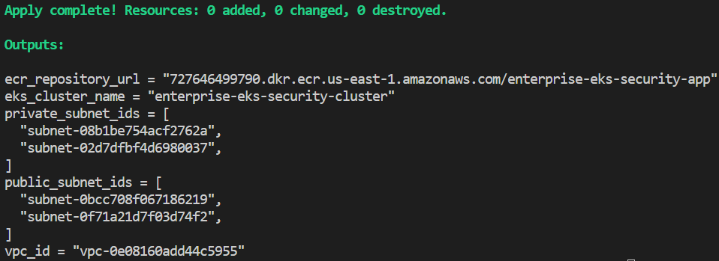

Step 16: Connect kubectl to Amazon EKS

- Connects your terminal to EKS:

aws eks update-kubeconfig --region us-east-1 --name enterprise-eks-security-cluster

Step 17: Verify Worker Nodes

- Confirms your worker nodes are running: kubectl get nodes

  - Return to Root Folder: cd ..

Step 18: Create Web Page

- Add the App Home page:

echo '<h1>Enterprise Kubernetes Security Platform on Amazon EKS is Running</h1>' > src/index.html

Step 19: Create Dockerfile

- Add the Dockerfile in /src:

FROM nginxinc/nginx-unprivileged:stable-alpine
COPY index.html /usr/share/nginx/html/index.html
EXPOSE 8080

Step 20: Get ECR URL

- Stores your ECR repository URL:

cd terraform && export ECR_URL=$(terraform output -raw ecr_repository_url) && cd ..

Step 21: Login to ECR

- Authenticates Docker with Amazon ECR:

aws ecr get-login-password --region us-east-1 | docker login --username AWS --password-stdin $ECR_URL

Step 22: Build Docker Image

- Open Docker Desktop and Run as administrator

  - Builds the Docker image: docker build --no-cache -t enterprise-eks-security-app ./src

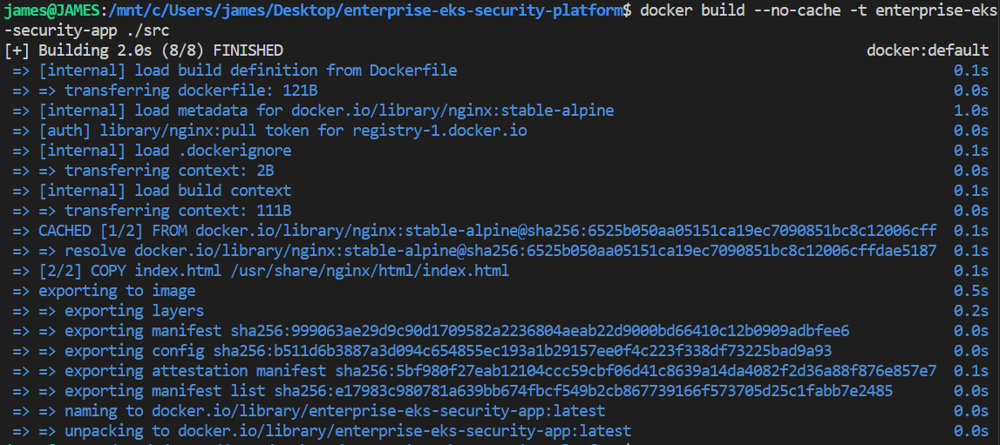

Step 23: Tag Docker Image

- Prepares the image for upload:

docker tag enterprise-eks-security-app:latest $ECR_URL:latest

Step 24: Push Docker Image

- Uploads the image to ECR: docker push $ECR_URL:latest

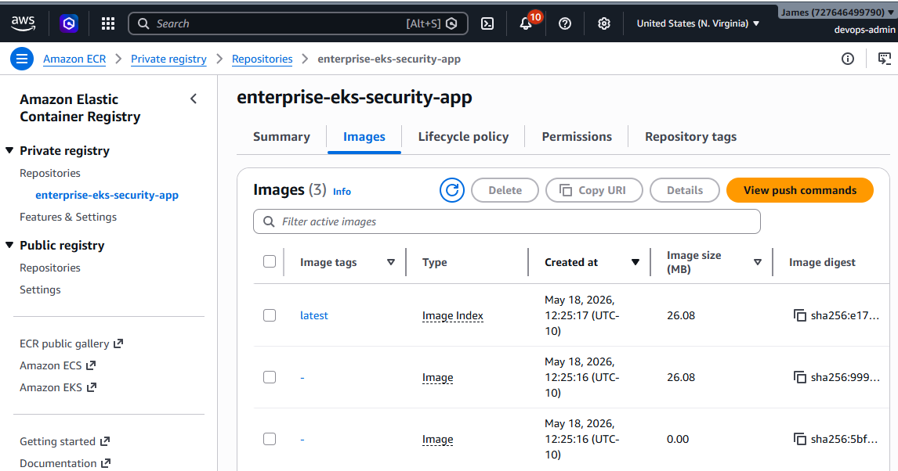

Step 25: Create Kubernetes YAML Files

- Add K8s config files:

touch k8s/namespace.yaml k8s/deployment.yaml k8s/service.yaml k8s/rbac.yaml k8s/network-policy.yaml

Step 26: Create Namespace YAML

- Opens the Kubernetes namespace file: vim k8s/namespace.yaml

apiVersion: v1
kind: Namespace
metadata:
name: enterprise-app
labels:
pod-security.kubernetes.io/enforce: baseline
pod-security.kubernetes.io/audit: restricted
pod-security.kubernetes.io/warn: restricted

Step 27: Create Deployment YAML

- Opens the Kubernetes deployment file: vim k8s/deployment.yaml

apiVersion: apps/v1
kind: Deployment
metadata:
name: enterprise-eks-app
namespace: enterprise-app
spec:
replicas: 2
revisionHistoryLimit: 2
selector:
matchLabels:
app: enterprise-eks-app
template:
metadata:
labels:
app: enterprise-eks-app
spec:
securityContext:
seccompProfile:
type: RuntimeDefault
containers:
- name: enterprise-eks-app
image: 727646499790.dkr.ecr.us-east-1.amazonaws.com/enterprise-eks-security-app:latest
ports:
- containerPort: 8080
securityContext:
allowPrivilegeEscalation: false
runAsNonRoot: true
capabilities:
drop:
- ALL

Step 28: Create Service YAML

- Opens the Kubernetes service file: vim k8s/service.yaml

apiVersion: v1
kind: Service
metadata:
name: enterprise-eks-service
namespace: enterprise-app
spec:
selector:
app: enterprise-eks-app
ports:
- port: 80
targetPort: 8080
type: ClusterIP

Step 29: Create RBAC YAML

- Opens the Kubernetes RBAC file: vim k8s/rbac.yaml

apiVersion: v1
kind: ServiceAccount
metadata:
name: enterprise-app-sa
namespace: enterprise-app
---
apiVersion: rbac.authorization.k8s.io/v1
kind: Role
metadata:
namespace: enterprise-app
name: enterprise-app-readonly-role
rules:
- apiGroups: [""]
resources: ["pods", "services", "configmaps"]
verbs: ["get", "list", "watch"]
---
apiVersion: rbac.authorization.k8s.io/v1
kind: RoleBinding
metadata:
name: enterprise-app-readonly-binding
namespace: enterprise-app
subjects:
- kind: ServiceAccount
name: enterprise-app-sa
namespace: enterprise-app
roleRef:
kind: Role
name: enterprise-app-readonly-role
apiGroup: rbac.authorization.k8s.io

Step 30: Create Network Policy YAML

- Opens the Kubernetes network policy file: vim k8s/network-policy.yaml

Step 31: Deploy Namespace

- Creates the enterprise-app namespace: kubectl apply -f k8s/namespace.yaml

Step 32: Deploy RBAC

- Adds basic least-privilege security: kubectl apply -f k8s/rbac.yaml

Step 33: Deploy Application

- Deploys your app to EKS: kubectl apply -f k8s/deployment.yaml

Step 34: Deploy Service

- Creates the internal app service: kubectl apply -f k8s/service.yaml

Step 35: Deploy Network Policy

- Adds network protection for the app: kubectl apply -f k8s/network-policy.yaml

Step 36: Verify Everything

- Confirms your app resources are running: kubectl get all -n enterprise-app

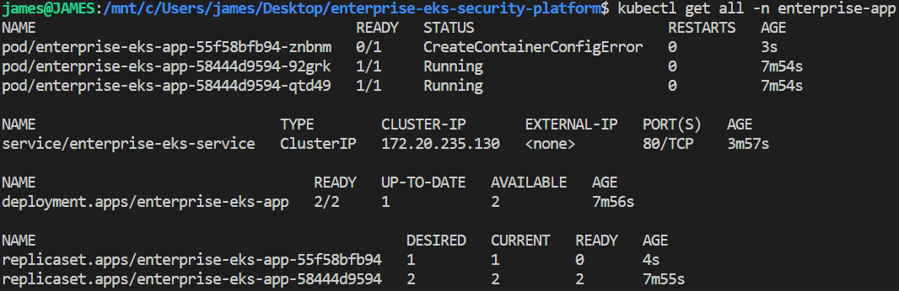

Step 37: Install Helm

- Verifies helm installation: helm version

Step 38: Add NGINX Ingress Repo

- Prepares Helm to install NGINX Ingress:

helm repo add ingress-nginx https://kubernetes.github.io/ingress-nginx && helm repo update

Step 39: Install NGINX Ingress Controller

- Installs NGINX Ingress:

helm repo add ingress-nginx https://kubernetes.github.io/ingress-nginx && helm repo update

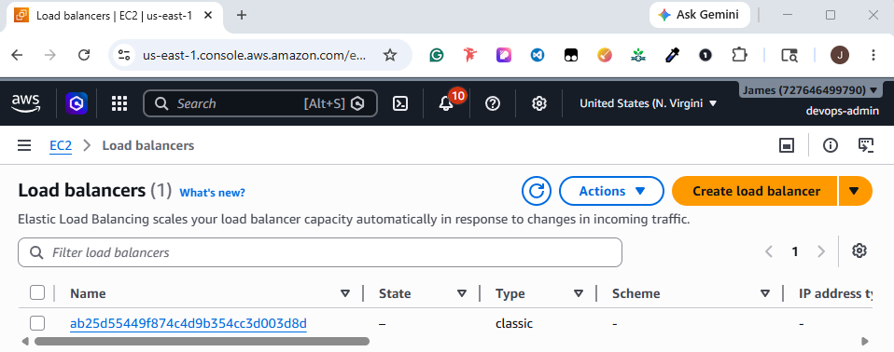

Step 40: Create Ingress YAML

- Opens the Ingress configuration file: vim k8s/ingress.yaml

apiVersion: networking.k8s.io/v1
kind: Ingress
metadata:
name: enterprise-eks-ingress
namespace: enterprise-app
spec:
ingressClassName: nginx
rules:
- http:
paths:
- path: /
pathType: Prefix
backend:
service:
name: enterprise-eks-service
port:
number: 80

Step 41: Apply Ingress

- Connects the load balancer to your app: kubectl apply -f k8s/ingress.yaml

Step 42: Get Public URL

- Obtains the public access address: kubectl get ingress -n enterprise-app

Step 43: Test the Public URL

- Go to: http://ab25d55449f874c4d9b354cc3d003d8d-505271511.us-east-1.elb.amazonaws.com

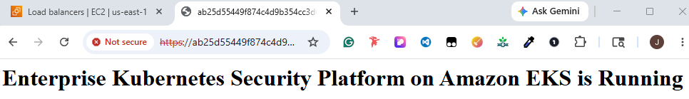

Step 44: Verify Ingress Controller Service

- Confirms the load balancer service: kubectl get svc -n ingress-nginx

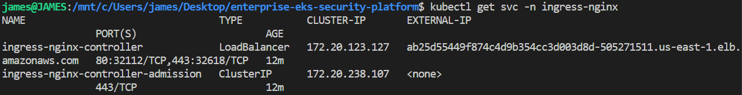

Step 45: Test App from Terminal

- Use curl to confirms the app is reachable:

curl http://ab25d55449f874c4d9b354cc3d003d8d-505271511.us-east-1.elb.amazonaws.com

Step 46: Verify Ingress

- Confirms the public route: kubectl get ingress -n enterprise-app

Step 47: Check eksctl

- Confirms if eksctl is ready: eksctl version

Step 48:

- Prepares IAM permissions for the AWS ALB Controller:

eksctl utils associate-iam-oidc-provider --region us-east-1 --cluster enterprise-eks-security-cluster –approve

Step 49: Download IAM Policy

- Downloads the IAM permissions policy:

curl -O https://raw.githubusercontent.com/kubernetes-sigs/aws-load-balancer-controller/v2.14.1/docs/install/iam_policy.json

Step 50: Create IAM Policy

- Creates the AWS ALB Controller IAM policy:

aws iam create-policy --policy-name AWSLoadBalancerControllerIAMPolicy --policy-document file://iam_policy.json

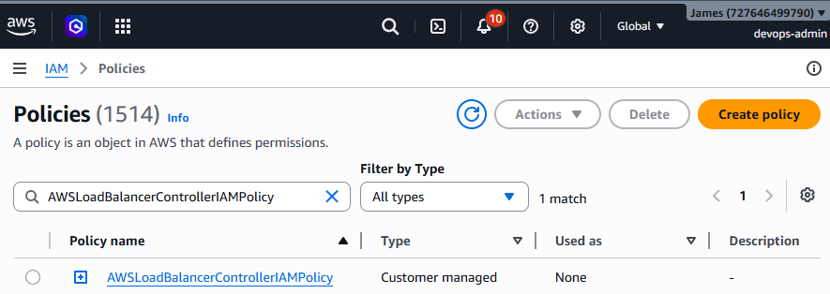

Step 51: Create IAM Service Account

- Gives the AWS ALB Controller AWS permissions:

eksctl create iamserviceaccount --cluster=enterprise-eks-security-cluster --namespace=kube-system --name=aws-load-balancer-controller --role-name AmazonEKSLoadBalancerControllerRole --attach-policy-arn=arn:aws:iam::727646499790:policy/AWSLoadBalancerControllerIAMPolicy --approve --region us-east-1

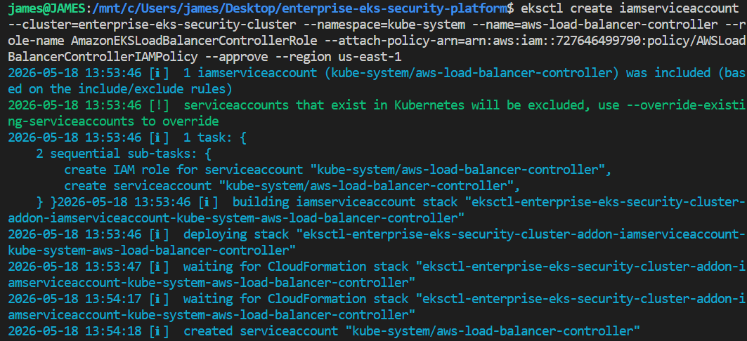

Step 52: Add AWS EKS Helm Repo

- Prepares Helm to install the AWS ALB Controller:

helm repo add eks https://aws.github.io/eks-charts && helm repo update

Step 53: Install AWS ALB Controller

- Install AWS ALB:

helm install aws-load-balancer-controller eks/aws-load-balancer-controller -n kube-system --set clusterName=enterprise-eks-security-cluster --set serviceAccount.create=false --set serviceAccount.name=aws-load-balancer-controller --set region=us-east-1 --set vpcId=vpc-0e08160add44c5955

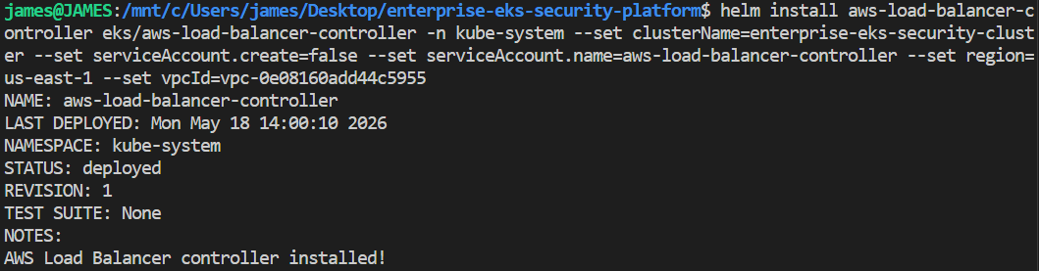

Step 54: Verify AWS ALB Controller

- Confirms the AWS ALB Controller is running:

kubectl get deployment -n kube-system aws-load-balancer-controller

Step 55: Verify Controller Pods

- Confirms ALB controller pods are healthy:

kubectl get pods -n kube-system | grep aws-load-balancer-controller

Step 56: Create ALB Ingress YAML

- Adds the Application Load Balancer route file: vim k8s/alb-ingress.yaml

apiVersion: networking.k8s.io/v1
kind: Ingress
metadata:
name: enterprise-eks-alb-ingress
namespace: enterprise-app
annotations:
alb.ingress.kubernetes.io/scheme: internet-facing
alb.ingress.kubernetes.io/target-type: ip
alb.ingress.kubernetes.io/listen-ports: '[{"HTTP":80},{"HTTPS":443}]'
alb.ingress.kubernetes.io/certificate-arn: arn:aws:acm:us-east-1:727646499790:certificate/b747c427-d915-4115-bcfb-15ae3434999f
alb.ingress.kubernetes.io/ssl-redirect: '443'
spec:
ingressClassName: alb
rules:
- host: caremedix.net
http:
paths:
- path: /
pathType: Prefix
backend:
service:
name: enterprise-eks-service
port:
number: 80

Step 57: Apply ALB Ingress

- Creates the Application Load Balancer: kubectl apply -f k8s/alb-ingress.yaml

Step 58: Verify ALB Ingress

- Checks if the ALB address is created: kubectl get ingress -n enterprise-app

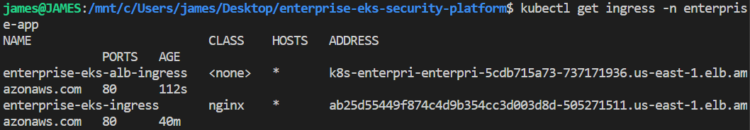

Step 59: Watch ALB Creation

- Checks ALB creation events:

kubectl describe ingress enterprise-eks-alb-ingress -n enterprise-app

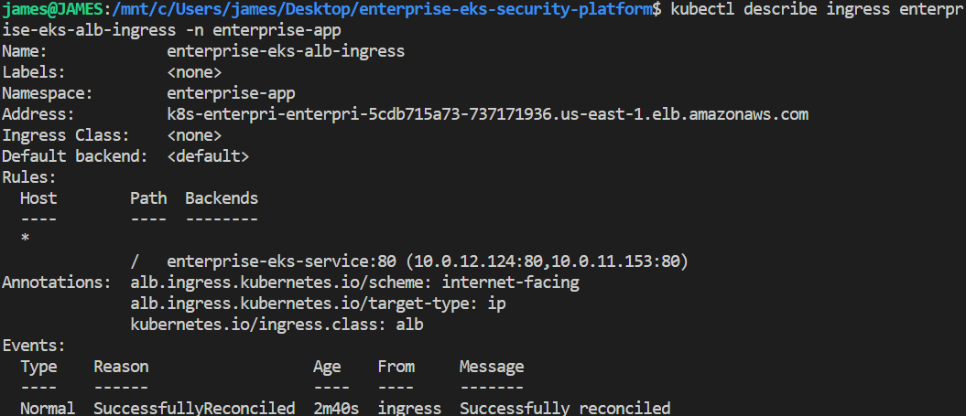

Step 60: Test ALB URL

- Use curl to confirms the ALB can reach your app:

curl http://k8s-enterpri-enterpri-5cdb715a73-737171936.us-east-1.elb.amazonaws.com

Step 61: Open ALB URL in Browser

- Go to: http://k8s-enterpri-enterpri-5cdb715a73-737171936.us-east-1.elb.amazonaws.com

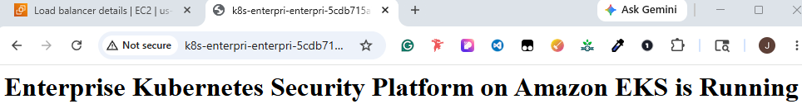

Step 62: Verify HTTPS Listener

- Check HTTPS is enabled:

kubectl describe ingress enterprise-eks-alb-ingress -n enterprise-app

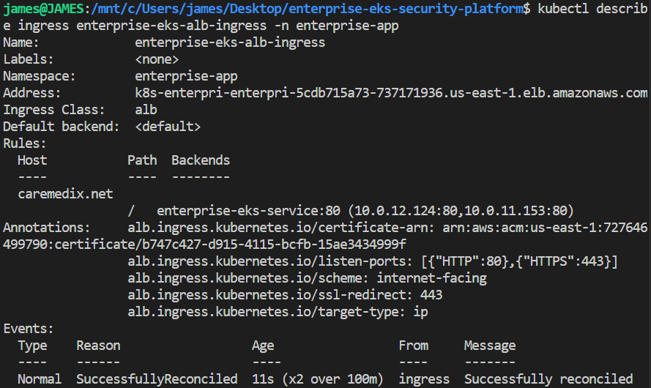

Step 63: Update DNS Record for caremedix.net in Cloudflare

- Go to: https://dash.cloudflare.com/ab57d5132936b1841fdc00de8e49c219/caremedix.net

  - In the bottom right, locate Domain Registration, pick: Manage domain registration
  - Click: Update DNS configuration
  - Choose: Add record
  - Enter the Type: CNAME
  - Specify the Name (required): @
  - Provide the Target (required): k8s-enterpri-enterpri-5cdb715a73-737171936.us-east-1.elb.amazonaws.com
  - For Proxy status, select: Proxied
  - Click: Save

Step 64: Test HTTPS Website

- Open browser: https://caremedix.net/

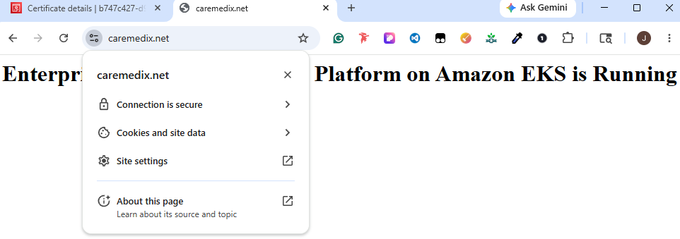

Step 65: Create AWS WAF Web ACL

- On the search bar, type: WAF & Shield

  - Click: Create protection pack (web ACL)
  - Under App category, choose: Enterprise & business applications
  - For the App focus, choose: Both API and web
  - Expand Add resources, select: Add regional resources
  - Pick: k8s-enterpri-enterpri-5cdb715a73
  - Click: Add
  - Choose: Essential rules
  - From Name and describe, enter: enterprise-eks-waf
  - Provide the Description – optional: Protects the Enterprise EKS Application Load Balancer
  - Under IP address > IP set for addresses to block: Leave as is
  - In IP addresses to block: Leave blank
  - For IP set for addresses to allow: Leave blank
  - From IP addresses to allow: Leave blank
  - In Countries, Block: Cuba (CU), Iran (IR), North Korea (KP), Russia (RU), Syria (SY), Venezuela (VE)
  - Under Logging destination type, choose: Amazon CloudWatch Logs
  - Click: Create protection pack (web ACL)
  - Enter the Log group name: aws-waf-logs-enterprise
  - For the Retention setting, type: 1 month (30 days)
  - On the Log class, choose: Standard
  - From KMS key ARN – optional: Leave blank
  - Click: Create

Step 66: Verify AWS WAF Rules

- Go to WAF & Shield > Protection packs (web ACLs) > enterprise-eks-waf

  - Click Manage rules
  - Expected Rules:
    - AWS-AWSManagedRulesAntiDDoSRuleSet
    - AWS-AWSManagedRulesCommonRuleSet
    - AWSManagedRulesKnownBadInputsRuleSet
    - AWS-AWSManagedRulesSQLiRuleSet
    - AWS-AWSManagedRulesLinuxRuleSet

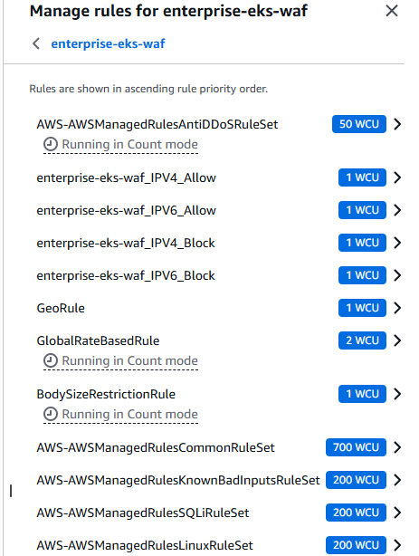

Step 67: Install Kubernetes Metrics Server

- Installs K8s resource monitoring:

kubectl apply -f https://github.com/kubernetes-sigs/metrics-server/releases/latest/download/components.yaml

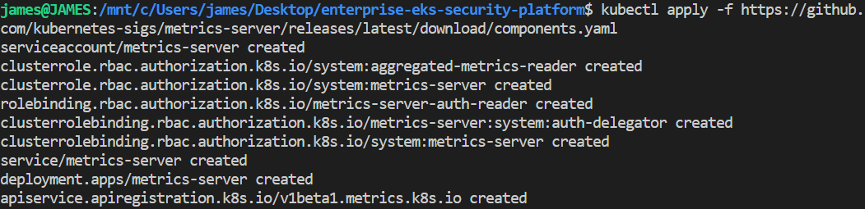

Step 68: Verify Metrics Server Pods

- Checks the Metrics Server pod is healthy:

kubectl get pods -n kube-system | grep metrics-server

Step 69: Verify Kubernetes Metrics

- Confirms CPU and memory metrics are working: kubectl top nodes

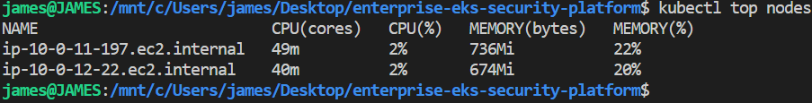

Step 70: Verify Pod Metrics

- Shows CPU and memory usage: kubectl top pods -n enterprise-app

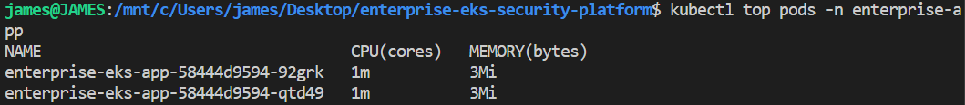

Step 71: Create Amazon CloudWatch Dashboard

- Go to CloudWatch > Dashboards

  - Click: Create dashboard
  - Enter the Dashboard name: enterprise-eks-dashboard
  - Choose: Create dashboard
  - Under Widget type, select: Line

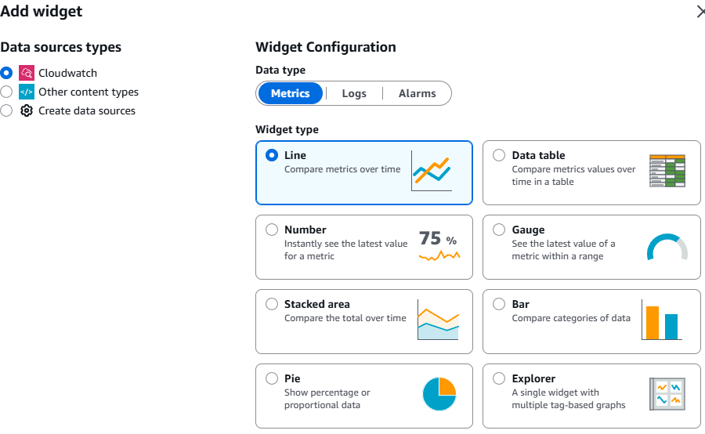

  - Proceed to: Next
  - Navigate to Browse > ApplicationELB > Per App ELB metrics
  - Select: app/k8s-enterpri-enterpri-5cdb715a73/afe7a7825d943c02 RequestCount
  - Choose: Create widget
  - Click: Save

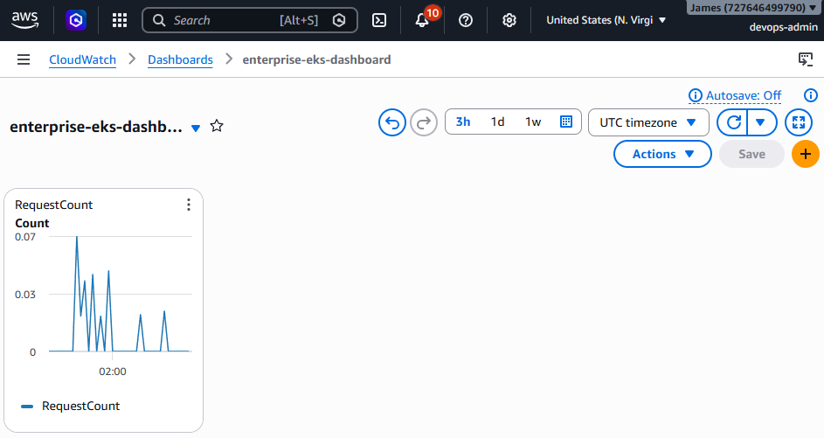

Step 72: Add Target Response Time Widget

- Select: +

  - For the Widget type, choose: Line
  - Proceed to: Next
  - Go to Browse > ApplicationELB > Per App ELB metrics
  - Pick: app/k8s-enterpri-enterpri-5cdb715a73/afe7a7825d943c02 TargetResponseTime
  - Select: Create widget
  - Choose: Save

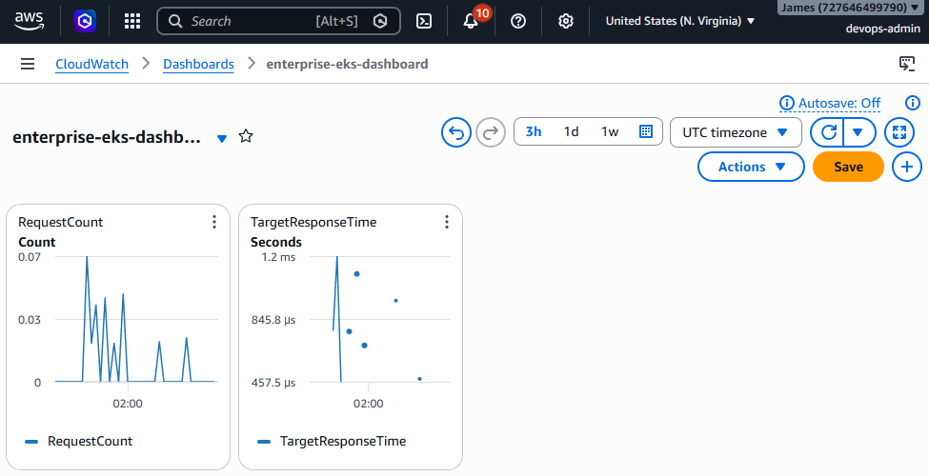

Step 73: Add Target Response Time Widget

- Choose: +

  - On the Widget type, choose: Number
  - Select: Next
  - Navigate to Browse > ECS/ContainerInsights > ClusterName
  - Choose: ContainerMemoryUtilization, ContainerCpuUtilization, NetworkTxBytes
  - Click: Create widget
  - Choose: Save

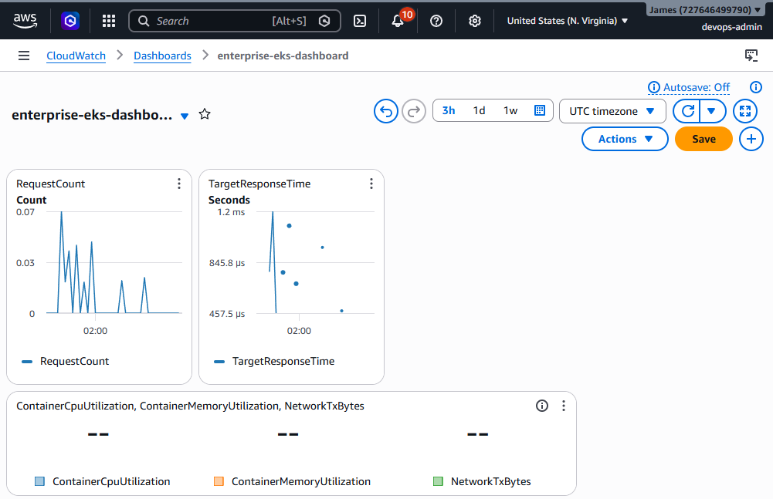

Step 74: Verify Kubernetes Resources

- Checks K8s application is healthy and running: kubectl get all -n enterprise-app

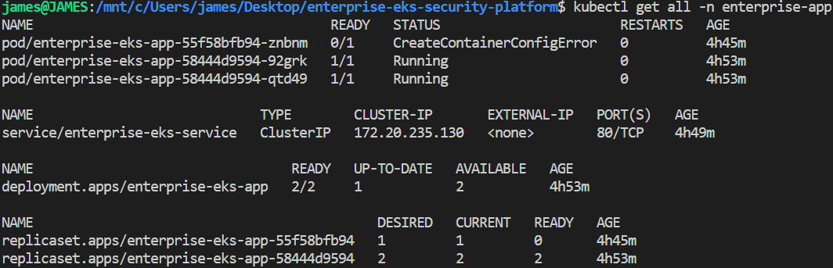

Step 75: Verify Ingress Status

- Checks ALB ingress is active: kubectl get ingress -n enterprise-app

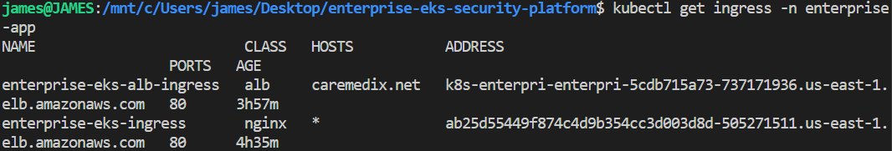

Step 76: Verify AWS Load Balancer Controller

- Checks AWS ALB Controller is running:

kubectl get deployment -n kube-system aws-load-balancer-controller

Step 77: Verify Controller Pods

- Checks ALB pods are healthy:

kubectl get pods -n kube-system | grep aws-load-balancer-controller

Step 78: Test Secure Website

- Go to: https://caremedix.net

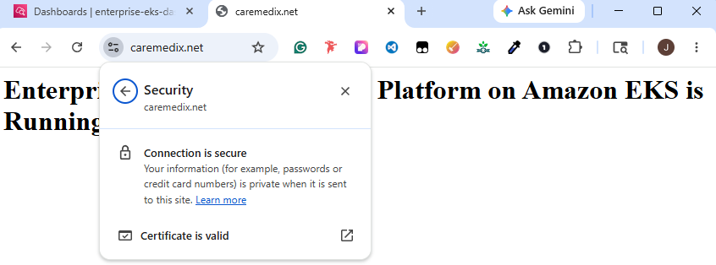

Step 79: Test Kubernetes Application Health

- Checks K8s application is healthy: kubectl get all -n enterprise-app

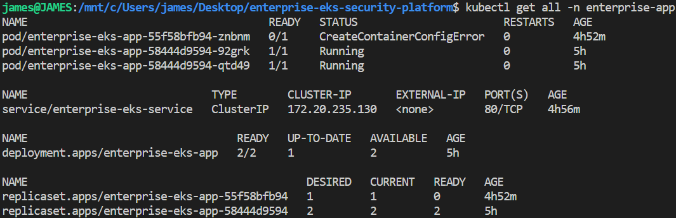

Step 80: Rebuild Docker Image

- Builds the fixed non-root NGINX image:

docker build --no-cache -t enterprise-eks-security-app ./src

Step 81: ag Docker Image

- Tags the image for Amazon ECR:

docker tag enterprise-eks-security-app:latest 727646499790.dkr.ecr.us-east-1.amazonaws.com/enterprise-eks-security-app:latest

Step 82: Push Docker Image

- Uploads the fixed image to ECR:

docker push 727646499790.dkr.ecr.us-east-1.amazonaws.com/enterprise-eks-security-app:latest

Step 83: Apply Kubernetes Files

- Updates K8s to use port 8080:

kubectl apply -f k8s/deployment.yaml && kubectl apply -f k8s/service.yaml

Step 84: Update your deployment.yaml

- Paste:

apiVersion: apps/v1
kind: Deployment
metadata:
name: enterprise-eks-app
namespace: enterprise-app
spec:
replicas: 2
revisionHistoryLimit: 2
selector:
matchLabels:
app: enterprise-eks-app
template:
metadata:
labels:
app: enterprise-eks-app
spec:
securityContext:
seccompProfile:
type: RuntimeDefault
containers:
- name: enterprise-eks-app
image: 727646499790.dkr.ecr.us-east-1.amazonaws.com/enterprise-eks-security-app:latest
ports:
- containerPort: 8080
securityContext:
allowPrivilegeEscalation: false
runAsNonRoot: true
capabilities:
drop:
- ALL

Step 85: Verify Pods

- Confirms the failed pod is fixed: kubectl get all -n enterprise-app

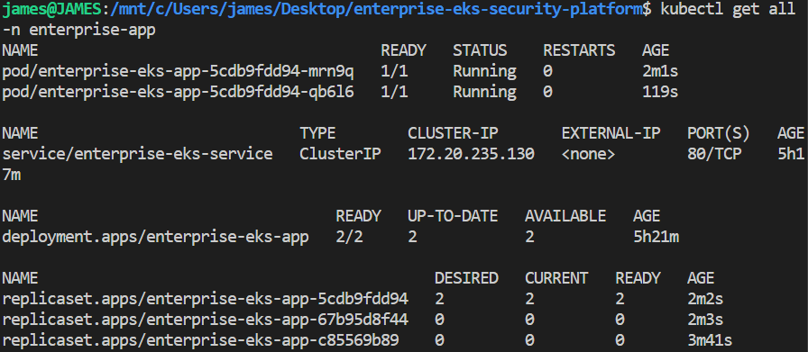

Step 86: Create GitHub Actions Workflow File

- Create GitHub folder:

mkdir -p .github/workflows && touch .github/workflows/deploy.yml

Step 87: Open deploy.yml

- Paste:

name: Enterprise EKS CI/CD

on:
push:
branches:
- main

jobs:
deploy:
runs-on: ubuntu-latest

steps:
- name: Checkout Source
uses: actions/checkout@v4

- name: Configure AWS Credentials
uses: aws-actions/configure-aws-credentials@v4
with:
aws-region: us-east-1
aws-access-key-id: ${{ secrets.AWS_ACCESS_KEY_ID }}
aws-secret-access-key: ${{ secrets.AWS_SECRET_ACCESS_KEY }}

- name: Login to Amazon ECR
uses: aws-actions/amazon-ecr-login@v2

- name: Build Docker Image
run: docker build --no-cache -t enterprise-eks-security-app ./src

- name: Tag Docker Image
run: docker tag enterprise-eks-security-app:latest 727646499790.dkr.ecr.us-east-1.amazonaws.com/enterprise-eks-security-app:latest

- name: Push Docker Image
run: docker push 727646499790.dkr.ecr.us-east-1.amazonaws.com/enterprise-eks-security-app:latest

- name: Configure kubectl
run: aws eks update-kubeconfig --region us-east-1 --name enterprise-eks-security-cluster

- name: Deploy Kubernetes Files
run: kubectl apply -f k8s/deployment.yaml && kubectl apply -f k8s/service.yaml

- name: Restart Kubernetes Deployment
run: kubectl rollout restart deployment enterprise-eks-app -n enterprise-app

- name: Verify Deployment
run: kubectl rollout status deployment enterprise-eks-app -n enterprise-app

Step 88: Create GitHub Repository

- Go to: https://github.com/login

  - Enter the Username or email address: jbanday808
  - Type the Password: YOUR PASSWORD
  - Click: Sign in
  - Choose + > New repository
  - Type the Repository name: enterprise-eks-security-platform
  - Provide the Description: Enterprise-Grade Amazon EKS Platform with Terraform, Docker, CI/CD, AWS WAF, Cloudflare, and CloudWatch.
  - Enabled: Add README
  - Leave as is: No .gitignore
  - For Add license, choose: MIT License
  - Click: Create repository

Step 89:

Step 90:

